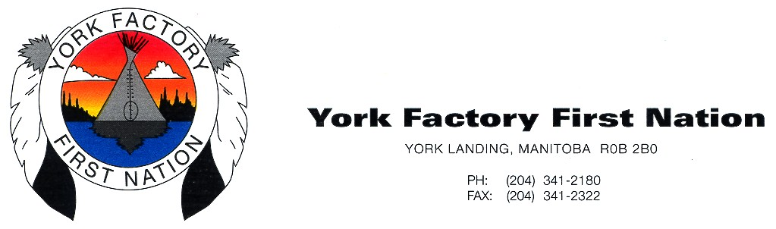

September 9, 2023
Dear Dr. Cary Miller, VP-Indigenous, University of Manitoba.
RE: Your help with York Factory First Nation Post-secondary Education and Research Plan

York Factory First Nation (YFFN) is excited to submit our education and research plan from our learning hub in York Landing serving eleven (11) First Nation communities in the Keewatin Tribal Council (KTC). At the KTC’s Indigenous Development of Economic Alliances (IDEA) conference in November 2022, the eleven KTC member First Nations agreed to form a strong alliance for Indigenous education and development that included the YFFN learning hub serving all the KTC communities.
This is a first step towards a state of the art education and community hub at the Pusiko Urban Reserve in Thompson, Manitoba to ensure Northern Manitoba communities receive access to postsecondary education in their territory. Please see the video documentation at https://www.youtube.com/watch?v=H4DJlMan550. This Indigenous-based hub is a much-needed alternative to systemic racism, colonial curriculum, and cultural shocks in colonial settings. The learning hub in York Landing is incorporating the “Next Seven Generations” concept which emphasizes that appropriate and relevant teaching today will positively impact the next seven generations.
We have had great success with all our eight students passing their first university course in Winter 2023. They succeeded because we have supports in place to assist and MITACS funding for the students. This fall of 2023 we wanted to expand to 13 students with most taking an Environmental Design course, which is proceeding well. However, we had barriers for admission of three smart young students, as they did not qualify, despite having their grade 12 degrees and are not over 21 years (mature).
Please we would benefit from your assistance with a few matters:
- Accept our invitation to speak and input into finalizing our education and research planning workshop of Pusiko Urban Reserve in Thompson, Manitoba ,which U of M Northern social work is helping to organize with Drs. Mallory Hill, Bonnycastle and Thompson on February 23rd and 24th, 2024.
- Assist us with advocating for admitting three YFFN students that each graduated from grade 12 on a trial basis to take one course each term, starting fall 2023 or winter 2024. These smart, hard-working students should have a chance to learn now, rather than having to wait to benefit from higher education opportunities until they become mature students at 21 years old.
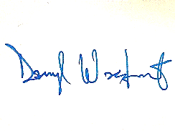
Sincerely,

Chief Darryl Wastesicoot
York Factory First Nation

Preliminary Post-secondary Education and Research Plan for York Factory First Nation Learning Hub

  - Contact Information

- Project Lead | - Darryl Wastesicoot, Calvin Chapman & Shirley Thompson
- Position Title | - KTC and YFFN Education Director & U of M PI
- Community / Org. | - York Factory First Nation
- Phone | - (204) 341-2180
- Email Address | CalvinC@mfnss.com, S.thompson@umanitoba.ca
- Mailing Address | - Box 257, York Landing, MB R0B 2B0

  - Community Vision and Future Opportunities

  - What is the community vision for the Education and Research Plan?
York Factory First Nation’s vision of establishing a learning hub in York Landing is to:
- Provide community-led post-secondary educational opportunities in homebuilding, engineering, entrepreneurship, governance, health, and human resources management by offering applied college and university programming to local students in a safe and appropriate learning environment with good technology and quality internet connectivity for online learning and virtual classrooms.
- Provide community-based educational options that will help to address the impact of intergenerational traumas of the forced relocation and residential school, and inequities exacerbated by the COVID-19 pandemic and racial violence on Indigenous educational attainment. The learning hub in York Landing can promote equity by serving northern Indigenous students for whom distance learning is most challenging. For instance, students from families without internet access or devices will have access to a safe environment conducive to learning, or Elder support that considers the full range of students’ social, emotional, cognitive, and physical needs.
- Provide a unique, innovative, collaborative, and community-focused approach for sustaining a competitive aboriginal workforce, driving the achievement of the United Nations’ sustainable development goals (of quality education, decent work and economic growth, reduced inequalities, and partnership for the goals) in northern and remote Indigenous communities as well as helping to bring our young people back home and leading us towards reconciliation.
- To pilot education and research plan at YFFN that can assist Pusiko development and help resolve the education blight and other issues in the community.
- The research plan would develop an education plan for YFFN and another for KTC considering the Next Seven Generations” concept to ensure appropriate and relevant teaching today will positively impact the next seven generations, steeped in traditional knowledge of local resources, harvesting, Cree language, and sustainable practices to build sustainable livelihoods, resilience, well-being, and assist reconciliation. Also the research plan would assist in the development of a housing, Indigenous food sovereignty and community plan for YFFN and for the Pusiko Urban reserve. This will lead to self-determination.
- Community-led education and research that meets the needs of our people and communities with the University of Manitoba, with KTC students involved in this research.
  - What are the community’s identified labour market needs?
.
- Land guardians for Indigenous-led protected areas  - Environmental scientist  - Environmental planner  - Geologists  - Land use planner  - Architects  - Engineers (Construction, Mechanical, etc.).  - Community developers | - Nurses  - Social workers  - Teachers  - Business developer  - Financial manager  - Human Resources manager  - Skilled Tradespeople in – carpentry, electrical applications, plumbing, and culinary arts

  - Identify future online learning the community would like to pursue. What courses or programs do the students or community members like to see.

Example: B.A., B.Ed., BSW, Trades, Business Admin, Nursing, Entrepreneur, etc.
- Indigenous studies
- Environmental science/studies, B.A., MNRM
- Geographer/Planner, Geographical Information systems and Mapping, B.A.
- Architecture and Interior Design, B. Arch
- Business Admin, B.A., MBA.
- STEM – Science, Technology, Engineering, and Mathematics, B.Sc.
- Teaching, B.Ed.
  - Educational Scan:
Which post-secondary institutions are the community students currently attending?
☐ Assiniboine Community College (ACC) |  | ☒ University College of the North (UCN)
☐ Brandon (BU) |  | ☐ Université de Saint-Boniface (USB)
☐ Canadian Mennonite University (CMU) |  | ☒ University of Manitoba (UM)
☐ Manitoba Institute of Trade Technology (MITT) |  | ☐ University of Winnipeg (UW)
☒ Red River College Polytechnic (RRCP) |  | ☐ Yellowquill College
☒ Other (list here): | - University of British Columbia (UBC)  - University of Victoria (UVic)  - Parkland College
  - What areas of study or programs are the current students enrolled in?

.
- B. Eng.,B.Sc., B.A., MNRM, Nursing, BSW, Business, Trades, PhD, B.Ed.
  - Student plan from winter 2023 to Winter 2024
- For winter 2023, Dr. Thompson provided computers and many educational opportunities for 8 students through the Mino Bimaadiziwin Partnership and MITACS.
- These 8 students applied for admissions this winter to take an online Introductory Environmental Studies course (ENVR 1000) taught by Leslie Goodman at University of Manitoba. All 8 succeeded and passed this university course.
- For fall 2023, YFFN cohort enrolled in EVDS 1600. We enrolled 10 students but wanted to enrol 13. Three students who passed grade 12 were not eligible. Many of these students are returning students who took ENVR 1000.
- For winter 2024, 13 people will enrol in Indigenous Peoples in Canada, Part 1 - 22573 - INDG 1220 - D01 and then will take Indigenous Peoples in Canada, Part 2 in the summer or fall 2024.The students want to find other applicable online courses including environmental two-eyed seeing courses, forest management, GIS, Indigenous land protection/planning, design, architecture, and business course
- Dr. Thompson has applied for MITACS funding and providing stipends for three terms for these students who are being supervised and mentored by Wikiwin.

  - Education and Research Plan Learning Hub
- York Landing reserve of York Factory First Nation (YFFN) is the geographical location of the proposed Indigenous community learning hub. YFFN is a remote First Nation community located along the eastern bank of the Nelson River at York Landing. YFNN is located roughly halfway between Lake Winnipeg and Hudson Bay, 116km from Thompson, Manitoba. YFFN members were relocated from their homelands to a small site on the southeast shore of Split Lake, now known as Kawechiwasik, or York Landing, in 1957. Their territory is vast on the coast of Hudson Bay but the removal created a physical barrier to land guardianship and traditional land uses.
- YFFN’s address – Box 257, York Landing, MB R0B 2B0
- New learning and research hub to be developed at Pusiko in Thompson, Manitoba.
- Strategic planning for education and development at Pusiko and YFFN in February 23, 24th of 2024 in Thompson, working with Northern Social work, with Drs. Mallory Hill, Bonnycastle and Thompson on February 23rd and 24th, 2024. It is a priority to invite Dr. Cary Miller and other leaders at the University of Manitoba, as a speaker and contributor.
  - If any, what other communities are you connected with?

:

- This Indigenous Learning Hub in York Landing is connected with eleven First Nation communities in the Keewatin Tribal Council (KTC) in Northern Manitoba and already includes some of these students and others (Nelson House and Garden Hill FN members).
- The Keewatin Tribal Council consists of the following member First Nations:
- Barren Lands (Brochet)
- Fox Lake (Bird)
- God’s Lake Narrow
- Manto Sipi (God’s River)
- Northlands (Lac Brochet)
- Bunibonibee (Oxford House)
- Sayisi Dene (Tadoule Lake)
- Tataskweyak (Split Lake)
- Shamattawa First Nation
- War Lake (Ilford) and
- York Factory (York Landing)
- Figure 1 below shows the location of the First Nations in KTC that will benefit from establishing the Learning Hub in York Landing.
- The Indigenous learning hub in York Landing, is increasing educational attainment with at least 5 students from each of the 11 First Nation communities in the KTC. This will also be reducing the need for First Nation students from the KTC communities to relocate to the city before having the opportunity to upgrade or complete their postsecondary education program’s prerequisite.
- The Indigenous learning hub at York Landing is helping bring members of the 11 First Nation communities under the KTC back home where they can feel comfortable learning and developing their capacity to address community issues such as poor housing, health risks and environmental and climate change impacts.

Figure 1: Map showing First Nation communities in Keewatin Tribal Council (KTC) connected to the learning hub in York Landing, Manitoba
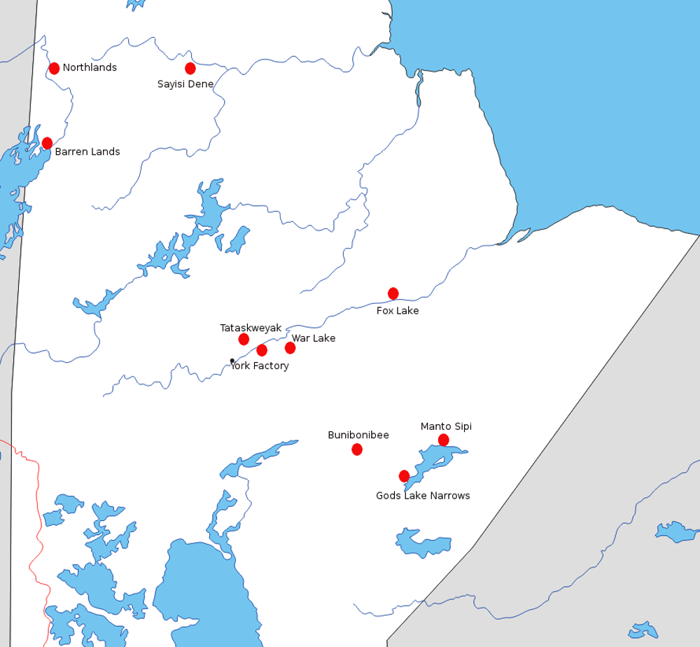

  - Space
The Learning Hub will allow for flexible studying and learning. It will provide quiet spaces for individual study, allowing learners to focus on their work outside of their household. The Learning Hub will also offer space for classroom learning.

  - Demonstrate how your community can meet the dedicated space (trailer, building etc.)
- Must possess four (4) season availability
- Fire safety approved and insured space
- Electrical – please indicate if any electrical upgrades are needed to function with internet and peripheral use requirements

- York Factory First Nation has a band building currently dedicated to employment and training activities. The building is located right in front of YFFN’s band office in York Landing, Manitoba. In other words, it is located at the center of the community and accessible to everyone, and easy to locate for users, especially during training events. This band building will be the dedicated space for establishing the learning hub proposed in York Landing. See the building sketch in Figure 2 below.
- While YFFN has the dedicated space to site the learning hub, we do need funding for equipping the space with more internet connectivity, computers, and ergonomic types of furniture.

Figure 2. Rough sketch of the proposed Band Building for establishing the Learning Hub in York Landing, Manitoba

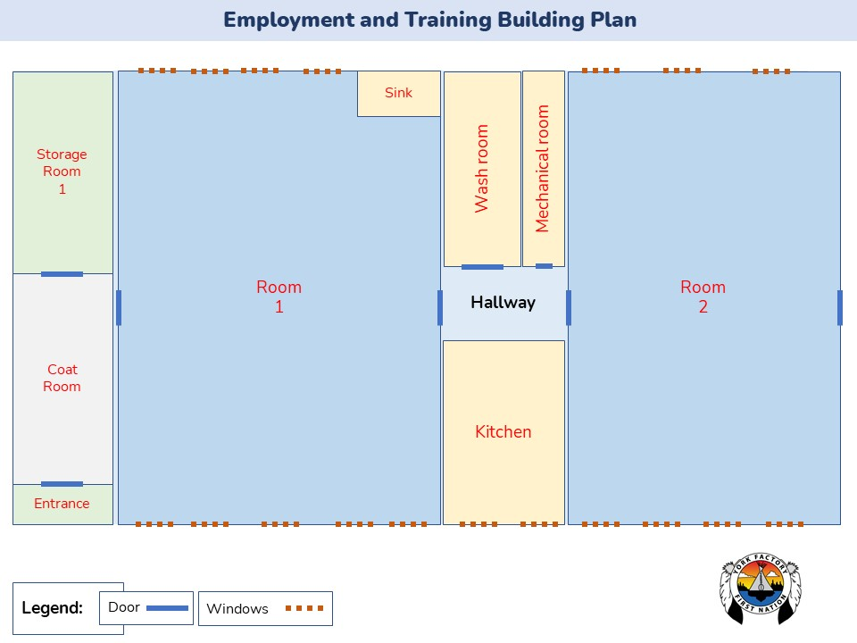

- Figure 2 above shows the rough sketch design of the band building with room 1 already transformed into a classroom. The building has two rooms (labeled Room 1 and Room 2 in Figure 2), a coat room for boots and hanging jackets. Room 2 is presently a kitchen and mini-restaurant services to band staff and trainees. The storage room is storing training equipment, mechanical room for maintaining electrical, internet and heating services in the building. The electrical and heating maintenance services are provided by KNC Electric which is owned by YFFN. Internet services are provided by Starlink to the building, supplying internet facilities to users in both Rooms 1 and 2. As a band building, it is insured with fire maintenance services and building inspections regularly conducted by the community housing manager and inspection officers.
- Room 1 space is usually used for training youths and community members on computer literacy, CV development, and job readiness training (see Photos 1 a-b in subsection 3.3). The space in room 1 can be optimized into a dedicated space for developing the learning hub in York Landing. This building is equipped with heating and electrical facilities, making it available for use as a learning hub all year round (or during the four seasons in Canada). The room has good electrical routes for internet and peripheral connections. Also, this classroom has fire safety with health and safety signals erected in proper locations. Currently, the room has access to internet connectivity via Starlink sponsored by the Employment and Training Department for students using the space for online training certification programs. Also, there are enough spaces to arrange chairs and tables for at least twenty students in each classroom.
- Room 2 space is used as a dining space where trainees eat their food, have side chats and have other discussions (see Photo 3 in subsection 3.3). This room is a bit smaller than room 1 (at least by a quarter). With dining chairs and tables, it takes up to 20 people at once. It has a big refrigerator (containing drinks and snacks) and a coffee and drinks spot for sale. With the goal of using this band building for a learning hub, this room 2 space will be redesigned and transformed into a learning hub café, where trainees and students can relax, have sharing circles, conduct lunch and learn sessions, hold webinars, meet with Elders for wellness support and much other learning promoting activities. Also, the learning hub coordinator will work with Sodexo restaurant currently using the kitchen in the building to provide mini-restaurant or café services to the learning hub users.
- This band building is able to work well as the learning hub site in York Landing as it has four seasons of availability for learning, regular fire safety procedures and maintenance services, and good internet connection facilities. However, there is a need to upgrade the building into a standardized learning hub. Through this initiative, York Factory First Nation will redesign and rearrange the proposed band building into a learning hub space, equipping the building with more internet connectivity, computers, software programs, and flexible seats to encourage collaboration. This is underway with University of Manitoba students and professors assisting with the design. Transforming this band building into an Indigenous learning hub in York Landing will increase local options for educational development (especially postsecondary) in northern and isolated First Nation communities in Manitoba.
3.2 Demonstrate how you can provide a dedicated flexible learning space:
- able to host classroom learning
- individual studying space
- other uses

- In the band building proposed as the learning hub site, rooms 1 and 2 will be transformed into dedicated flexible learning spaces.
- Room 1 has a TV for presenting, a whiteboard marker for classroom learning or demonstrations, and chairs and tables can be rearranged and demarcated to create a dedicated space for individual learning activities. This room has over 20 office chairs and long tables which students use for studying, and good electrical fittings for charging their laptops and learning devices.
- Considering the ongoing COVID-19 crisis, room 1 is equipped with protocols and measures guaranteeing students’ health and safety with personal protective equipment, sanitizing station, a sink, and a washroom for handwashing. Also, this room has enough space to accommodate the COVID-19 indoor sitting arrangement.
- Room 2 is a flexing space that will be redesigned and transformed into a learning hub café, where trainees and students can relax, have sharing circles, conduct lunch and learn sessions, hold webinars, meet with Elders for wellness support, and many other learning promoting activities. Also, the learning hub coordinator will work with Sodexo restaurant currently using the kitchen in the building to provide mini-restaurant or café services to the learning hub users.
- While the rooms in the band building are already dedicated learning spaces, instructors and trainees are required to book the rooms before use with the Employment and Training Coordinator. Booking the rooms for training or learning purposes is flexible but involves protocols for usage. The existing usage protocols for room usage already ensure that all equipment and facilities installed in the classroom are properly monitored and used in a culturally and environmentally friendly manner.
3.3 Demonstrate how your chosen space can host a minimum of 20 occupants.

Attach any blueprint diagrams or photos of the proposed learning space.
- Figure 2 shows the hand sketch design of the band building. The building has two rooms with a classroom space that is currently used for training youths and community members on computer literacy, CV development, and job readiness training. Room 1 in the band building will be optimized into a dedicated space for developing the learning hub in York Landing.
- Room 1 can host 30 people at once for learning purposes such as workshops, open house information, and training programs. Recently, room 1 was used to host over 20 YFFN members for an open house information session, engaging the Indigenous youths on the Indigenous-led community-based homebuilding training program called Wikiwin starting in January 2023 in York Landing. Also, room 1 is equipped with a sink facility and a COVID-19 sanitizing station for people to clean and wash their hands, preventing COVID-19 transmission during programs. See photos 1a-b showing the side views of Room 1 in the band building.
- Room 2 is a little bit smaller than Room 1. However, it can host up to 30 students when redesigned into a student café room in the learning hub where students can sit and relax to do assignments, dine, have a sharing circle or meet with an elder for mental health and wellness support.
- Photos of the classroom below show one of the classrooms has the capacity to host a minimum of 20 students. Also, the pictures show the classroom has a TV for presenting, a whiteboard marker for classroom learning or demonstrations, a photocopier, and chairs and tables dedicated to learning activities.
Photo 1(a-b): Room 1 in the band building proposed to be a learning hub in York Landing, Manitoba
1a)
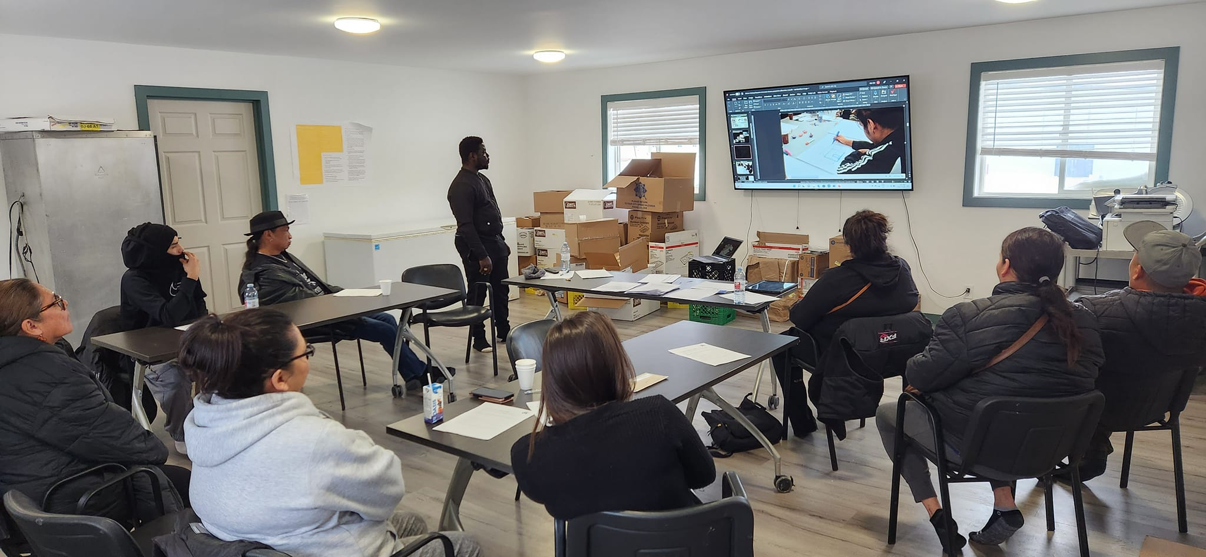

Photo 2: Kitchen in the band building proposed as learning hub site in York Landing

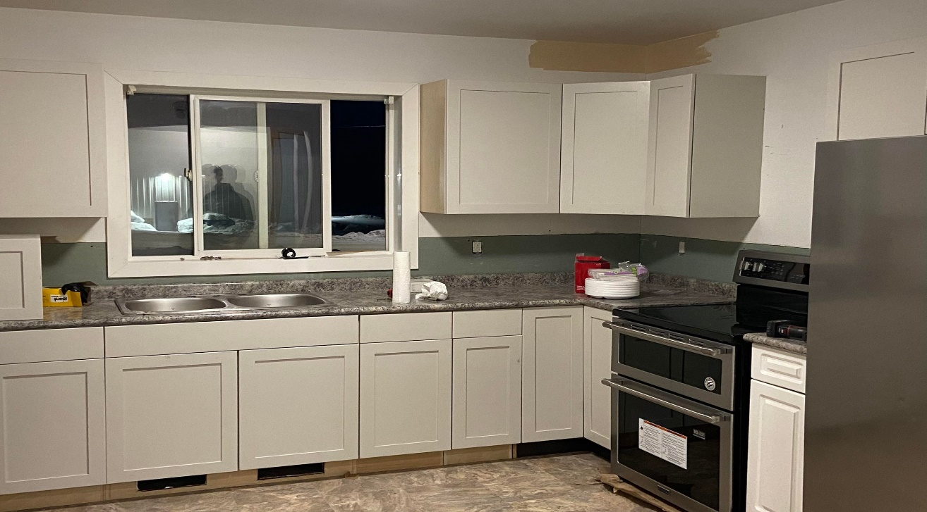

Photo 3: Room 2 in the band building proposed as a learning hub in York Landing, Manitoba

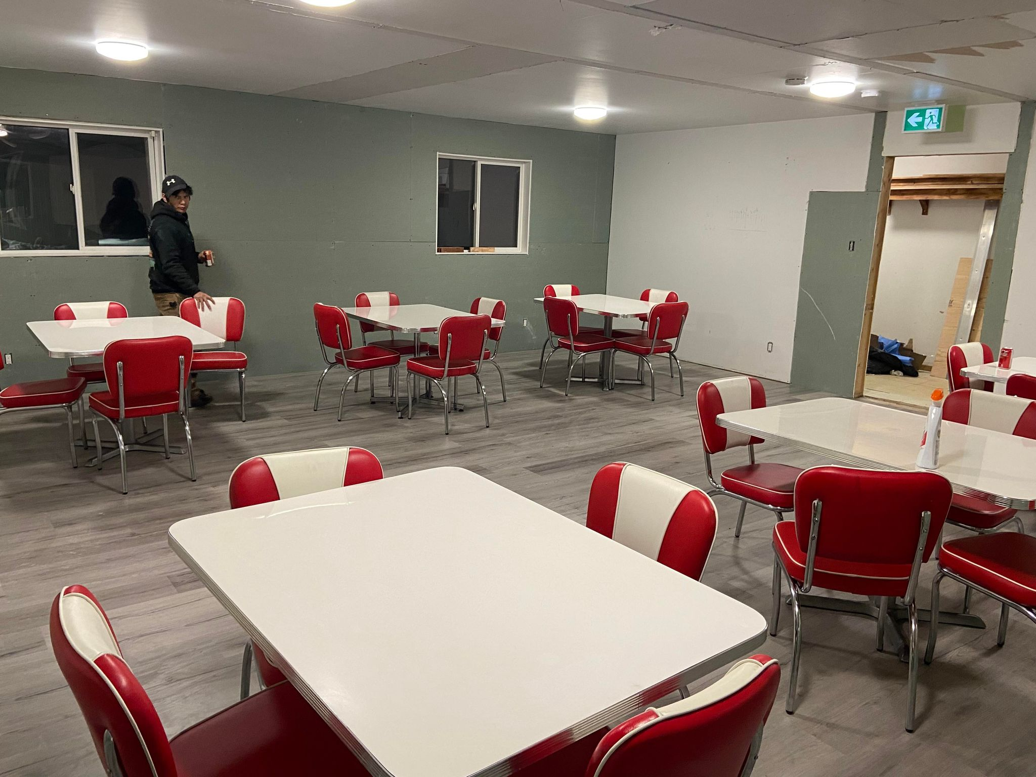

  - Technology
Technology Solutions – In the rural communities that internet connectivity is a concern. Through this partnership, the UM Learning Hubs Manager and the community will collaborate to find attainable internet solutions, as well as procure the necessary hardware and software for online learning.

Below are the technological specifications we would work together to achieve:

- Internet bandwidth which meets the requirements for remote learning:
Stable internet/speed of internet connection – Wired or Wireless connectivity. Ideally a wired network connection or, if not available, a wireless internet connection that meets the following specifications:
- Wireless-AC (802.11ac) access point (router or modem)
- Computer that supports Wireless-AC (802.11ac)
- Computer location within 10m (30ft) of the access point (router or modem)
- Has a minimum of 5 Mbps of download and 2 Mbps of upload capacity

- Hardware and software:
- Desktop computers and/or laptops* with adequate processors and memory to support online learning platforms.
- Operating Systems – OS 10.4 or higher for Mac, Windows 7 or higher for PC
- Web browsers – Chrome, Edge, Firefox, Safari

* Laptops can manage security easier, are portable and students can take them home to do work offline

- IT capacity and support for the various technology platforms used by each institution.

- Internet support – e.g., Starlink has FSET to provide ongoing IT support.

  - Can you identify a community IT point person to liaison with external internet parties, more specifically, someone who understand the above internet and computer specifications.
- Ashley Chapman - whitendn204@gmail.com
  - Share the current internet carriers the community utilizes.

Example: Explornet, Shaw, BellMTS, Starlink, other satellite carriers.
- Starlink – currently has it working in the band building proposed to host the learning hub in York Landing
- Broadband Communications North (BCN)

  - Barriers
This section will identify any barriers that require attention or assistance. This is important in understanding how we can work in partnership to troubleshoot obstacles and support Indigenous youth in their educational journeys.

  - Outline any foreseeable barriers, obstacles or issues that will require assistance.

Example: infrastructure, space upgrades, electrical, internet capability, human resources, etc.

- Space upgrades – assistance is required to redesign the E&T classroom into a learning hub.
- Internet capability – assistance required to procure and install more internet facilities required for the learning hub.
- Human resources – many FN youths need training and support in using technology. Assistance will be required in providing on-site IT support and maintenance personnel.
- Funding for purchasing expensive online training tools and equipment and providing honorariums to Elders giving support to the learning hub users.
- Infrastructural expansion – assistance in procuring a trailer as an extension to the learning hub, foreseeing that students from other communities will be using the hub and the need to follow covid-19 seating arrangements.
- Food insecurity among students – low educational attainment among First Nation students is linked to food insecurity. State food insecurity rate. Assistance is required in providing a breakfast program where students using the learning hub will have access to coffee and light breakfast and be able to concentrate and focus during learning.
- Loss of motivation for postsecondary education – many First Nation youths and young adults lack the motivation to attend postsecondary education institutions due to the impacts of the intergenerational trauma of residential school and systemic racism experienced in colleges in the city. There is a need to revitalize Indigenous youth’s interest in postsecondary education as we provide options for them to transition from Western educational institutions into an Indigenous-led learning hub. YFFN will need support in implementing strategies that will help to improve Indigenous youth’s motivation to complete postsecondary education. Strategies include but are not limited to rewarding Indigenous youths that have achieved postsecondary education certificates at the learning hub with awards and creating honors roll for them at the learning hub. Interviewing students and conducting a regular survey to document the impact of the learning hub on students’ motivation and social relations. Also, the loss of motivation for postsecondary education among Indigenous youth is the long duration required to complete the programs. In the long term, special project-based micro-credential courses from professional organizations or international agencies such as UNDP focusing on Indigenous land guardianship, environmental justice, Wilderness First Aid training, emergency and disaster management, and Indigenous-led area-based conservation strategies in northern Canada can be made available at the learning hub. YFFN will need the support and resources required for installing Massive Open Online Courses (MOOC) at the learning hub for Indigenous youth to earn certificates from different programs available online from different Canadian institutions and professional organizations.

  - Human Resources
Demonstrate how your community can meet the following human resource requirement for each of the required positions.

6.1 Full-time In-community Learning Hub Coordinator (40 hours per week)

A training coordinator will support students in using online learning platforms; raise awareness of the Learning Hub and services available; guide students in accessing academic and support services; develop and deliver wrap-around supports and other programming. The Learning Hubs Manager will work with the community to develop a detailed job description, tailored to the community’s goals for their Learning Hub.

- The experienced community member who can support students in using online learning platforms; raise awareness of the learning hub and services available, guide students in accessing academic and support services, develop and deliver wrap-around supports and other postsecondary programming.
- To fill the in-community learning hub coordinator role, the employment and training coordinator will work with the learning hubs manager to develop terms of reference, and posters for advertising the position and involve the Chief and Council in the hiring process. A qualified YFFN member living in the community will be considered first for filling this role. However, a qualified non-YFFN member that is willing and committed to staying in the community as well as working full-time as an in-community learning hub coordinator will be considered in case no YFFN member is able to fill this role.
- Further, our community will provide the in-community learning hub coordinator with access to office space and other necessary support required to optimally function in this role.
- Supports include Designated Community IT personnel or Tech Support and Maintenance workers

- The employment and training coordinator will work with the community IT point person to determine the terms of reference, skills required, and the number of hours for designated community IT personnel or tech support roles.
- Posters for advertising the position will be developed and the Chief and Council will be involved in the hiring process. A qualified YFFN member living in the community will be considered first for filling this role. However, a qualified non-YFFN member that is willing and committed to staying in the community as well as working full-time as a designated community IT personnel will be considered in case no YFFN member is available to fill this role.
- Also, our community will provide the designated community IT personnel with access to office space and other necessary support required to optimally function in this role.

- The employment and training coordinator will work with the community IT point person to determine the terms of reference for the maintenance worker role.
- Posters for advertising the position will be developed and the Chief and Council will be involved in the hiring process. A qualified YFFN member living in the community will be considered first for filling this role. However, a qualified non-YFFN member that is willing and committed to staying in the community as well as working full-time as a maintenance worker will be considered in case no YFFN member is available to fill this role.
- Also, our community will provide the maintenance worker with access to office space and other necessary support required to optimally function in this role.

  - Supports
For many students, an online learning environment can create additional stress and anxiety. Some students struggle to stay motivated and engaged. For these reasons it is important that learners have access to academic and wellness/holistic supports (emotional, spiritual). Many students prefer access to Elders and/or cultural supports to assist them.

Demonstrate how your community can meet each of the following supports:

  - Academic Supports
- Academic mentorship is very important for educational programs to succeed in northern First Nations communities, including York Factory First Nation.
- For this Indigenous learning hub program, over 29% of YFFN members have postsecondary certificates, diplomas or degrees. These members would be invited to form a northern Indigenous mentorship network providing academic support required by Indigenous youths to kickstart and complete their postsecondary education programs. Academic support from the Indigenous mentorship network will be provided in-person by local teachers and retired Indigenous experts living in the community.
- Also, Indigenous mentors in the mentorship network will be able to provide academic support to Indigenous users of the learning hub – virtually. Once the Indigenous mentorship network is launched, the learning hub users will have access to booking support sessions with any mentor of their choice.
- To launch the northern Indigenous mentorship network in Manitoba, YFFN will be leading the process through this learning hub partnership initiative. YFFN will reach out to other member First Nation communities under the Keewatin Tribal Council to announce the development of this mentorship network, requesting Indigenous experts and professionals from the communities to join the network. With high-level supervision and support from the Chief and Council, the YFFN employment and training department as well as the education authority will screen and add Indigenous mentors to the network on a rolling basis.
- Further, YFFN is involved in the Mino Bimaadiziwin partnership at the University of Manitoba. Through this existing partnership, Indigenous users of the learning hub in York Landing will have access to academic support from the Indigenous and non-Indigenous academics and faculty at the University of Manitoba present in the partnership. Also, academics and faculty outside of the University of Manitoba that are present in the partnership will be available to provide postsecondary educational support, such as Dr. Alex Wilson who is an Indigenous scholar from the University of Saskatchewan.

  - Access to Elders, Cultural supports, and resources
- For the learning hub to succeed in York Landing, YFFN will create access to elders, cultural supports, and resources through the ongoing land-based educational programs and the new Indigenous mentorship network.
- York Landing’s land-based program currently involves the elders transmitting Indigenous values and knowledge, improving Indigenous wellness and socialization in the community. Elders from this program will be actively providing wellness and cultural support required by youths at the learning hub.
- Indigenous mentorship network is also an avenue for the learning hub users to access elders and cultural support as well as resources required for success in their programs of study.
  - Wellness supports and resources
- With the support of YFFN’s health team, the learning hub users will be able to access mental health resources and support for improving their wellness and well-being during their postsecondary education programs.
- Support line and contacts of Indigenous wellness staff will be shared as public information in the learning hub notice board.
  - Other: please specify
- The Chief has taken Adult Education courses and taught the 2-year Homebuilding program with Anokiwin Training Institute and with Dr. Thompson from the Faculty of Environment, Earth, and Resources in remote communities. After teaching this program with the university and a college involved the commitment to education is informed by past positive experiences that resulted in excellent outcomes.

  - Sustainability
Beyond the provided funding, the applicant is required to demonstrate how they can financially sustain the continuance of the established learning hub.

8.1 Should the Learning Hub prove successful, what opportunities can your community pursue for sustainable funding?
- York Factory First Nation is committed to pursuing funding partnerships for building the capacity of Indigenous youth towards sustainable Indigenous development. As a result, YFFN has developed a social enterprise for training youths and young adults which will continue to support the learning hub, helping to build the community’s capacity for trades and other postsecondary programs. This social enterprise model incorporates the “Next Seven Generations” concept which emphasizes that appropriate and relevant teaching today will positively impact the next seven generations (Pidgeon, Munoz, Kirkness, and Archibald, 2013; LaDuke, 1999).
- Also, YFFN will maintain ongoing and pursue new partnerships with local and international organizations supporting community-based education (such as Mino Bimaadiziwin), especially in the remote and isolated Indigenous communities, to access holistic support (financial, advisory, mentorship, and educational) required to sustain the learning hub established in York Landing.
- To ensure technology and internet facilities are sustainably provided at the learning hub, York Factory First Nation will cultivate long-term relationships with existing partners (such as KNC Electric and YFFN Hardware Store) and develop new partnerships with technical service providers, especially in the remote and isolated Indigenous communities, to provide holistic support (financial, advisory, mentorship, and educational) required to sustain the learning hub established in York Landing.
- With Keewatin Tribal Council (KTC) supporting the learning hub initiative in York Landing, York Factory First Nation will work with the other member First Nation communities to collectively seek funding from provincial and federal governments or agencies to expand the learning hub facilities as adoption rate increases.

  - Partnership and Development

9.1 Identify the designated parties who will be involved and their roles:
- Designated parties within the community (e.g., signing authorities) who will enter into partnership and development for the Learning Hub.
Example: Chief, Board member, CEO, Tribal Council, Education Director, Finance.
- Chief- provide support (building, materials, etc.) and encouragement for the program with regular meetings to ensure its success and resolve any problems.
- 4 Councillors- provide support and encouragement for the program with regular meetings to ensure its success.
- Education director – provides leadership in program development and supports tutoring.
- Employment and training director – provide safety courses and safety equipment for students and work
- YFFN’s CFO- to ensure finances are in place and in order.
- Coordinator for learning hub/Wikiwin Training Centre – maintain a safe computer centre and classroom
- Wiikiwin CEO- develop MITACS and funding for students
- Mino Bimaadiziwn and Quality in the Built Environment SSHRC partnership – Drs. Thompson, Mallory-Hill, Garcia, and Bailey – programming, and Dr. Thompson are committed to supervising and writing student MITACS.
- Keewatin Tribal Council – promote the program to their 11 communities and hope to expand the program to have a hub in each community and their proposed KTC urban reserve in Thompson.

  - Deliverables
As part of the partnership, financial and narrative reports will be required. Deliverables will be required from various sources within the community. Demonstrate how you will meet each of the deliverables:

  - Deliverables by the In-community Coordinator
- Progress Reports: Regular meetings between the community partner and the Learning Hubs Manager. A concise written progress report detailing the meeting, any milestones and ongoing tasks, etc.
- Bi-annual Narrative Reports – completed by the In-community Learning Hub Coordinator. Dates set in MOA.
- Develop and define measures of success. From the Indigenous youth and the community point of view, what would the measures be of a successful Learning Hub?
- York Factory First Nation is outcome driven. Beyond implementing the learning hub initiative, YFFN is focused on ensuring that positive outcome is achieved through the initiative by tracking and reporting the progress of the initiative to partners involved on a regular basis. This involves building solid engagement through regular update meetings and communicating progress with partners involved in the learning hub initiative. To ensure that regular updates and progress reports are provided, YFFN will ensure that this responsibility is included in the in-community coordinator’s Terms of Reference. Basically, reporting and communication skills (oral and verbal) will be considered important factors in determining the final candidate that will fill the position.
- The progress report will be developed and shared by the in-community coordinator with the learning hubs manager, detailing notes from meetings, the actions taken, and milestones achieved in the initiative. The in-community coordinator will work with the learning hub manager to determine the preferred means of communicating progress reports and regular updates about the learning hub established in York Landing. Update meetings can be held virtually via zoom or Microsoft teams on a biweekly or monthly basis. Also, concise written progress reports detailing the meeting and ongoing tasks will be shared with the learning hub manager on a regular basis as agreed in the MOA.
- Further, the evaluation of the learning hub initiative will follow the Ownership, Control, Access, and Possession (OCAP) protocol, measuring the success of the learning hub from the perspectives of the Indigenous youth and community members. The OCAP protocols establish how First Nations’ data and information were collected, protected, used, or shared (First Nations Information Governance Centre [FNIGC], 2020). Following the OCAP protocol, YFFN will work with the Mino Bimaadiziwin partnership to collect a longitudinal survey using an existing research ethics protocol titled - “Northern Teaching Lodges: Learning Partnership for Community Development and Mino Bimaadiziwin in First Nation Communities” and the WISE survey.
- The in-community coordinator will work with graduate researchers at the UoM to revise the existing ethics for the evaluation survey questions to measure the success of this learning hub initiative, and the amendments request will be submitted for approval from the University of Manitoba’s Joint Faculty Research Ethics Board. No names and no identifying information will ever be reported regarding knowledge dissemination and sharing, with data grouped to hide identifying information. Summary results with all names and identifying information removed will be provided to the First Nation employment and training director, the chief and council, and the learning hub manager for feedback within one month of completion. Afterward, the research findings will be reported in the bi-annual narrative reports posters, journals, conferences, and other ways that the education director and chief feel are appropriate to improve learning hub outcomes, change educational policies and build community support services.
  - Financial Deliverables
- Quarterly Finance Reports – detailed financial accountability by a Finance Officer/Comptroller. Dates set in MOA.
- Receipts for any services or purchases
- Payment forms for honorariums
- York Factory First Nation’s Chief Financial Officer (CFO) will be responsible for the financial deliverables. The CFO is experienced in financial reporting and will provide quarterly finance reports either in pdf or excel format or any other format as required and documented in the MOA. The CFO will ensure that receipts for honorariums, door prizes, or any services and purchases are filed and kept safe for proper reporting, as required.

