Expression of Interest (EOI) for
Indigenous-Led Area-Based Conservation (ILABC)

GENERAL INFORMATION
Instructions to complete the form and information about the process can be found in the Applicant Guide and the Frequently Asked Questions. Note that the size of the boxes that are included after each question are there to provide an example of the approximate length of the expected answer.
Eligibility: your project must meet specific criteria to be eligible for ILABC funding. The questions in the form will enable ECCC to assess the following criteria. Please consult the application guide to ensure that all necessary information is included.
- Project must be Indigenous-led.
- Project area must be assessed for protection or conservation through interim protection, established as a protected area or recognized as another effective area-based conservation measure (OECM) by 2025 or 2030. Priority will be given to projects that are expected to be protected by 2025.
- Project must have the support of the relevant provincial or territorial government, and others with interest in the land. Should the project be funded, the province or territory and project recipient must be willing and able to report the project as a protected area or OECM or regional equivalent designation as part of Canada’s conservation targets (i.e. protecting 25% of Canada’s lands and waters by 2025 and 30% by 2030) once the project has achieved the criteria to be a protected area or OECM or regionally equivalent designation. Projects are reported by the corresponding province or territory to the Canadian Protected and Conserved Areas Database found here.
- The project has positive environmental and cultural impacts on the community, such as increasing connectivity, climate change adaptation or mitigation, and/or habitats for species at risk, language, transfer of knowledge between Elders and youth.

Applicants that submit an EOI that is accepted for funding will be notified in Summer 2023.

Note:
- New projects cannot be funded if financial and project reporting for T1C is not up to date.
- Applicants submitting EOIs for projects in Nunavut must contact the program at CZMA-ILABC@ec.gc.ca prior to submitting their EOIs.

If you have additional questions about the form and/or instructions, please contact Indigenous-Led Area-Based Conservation at czma-ilabc@ec.gc.ca.

A. APPLICANT INFORMATION
Name of Applicant Organization/Community/Hamlet/Nation:

Principal contact(s) information for project.

Name: Vincent Norman Wood | Job Title: Regional Coordinator, Lands, Resources & Environment - Island Lake Tribal Council (ILTC)
Email: vincentnwood@gmail.com | Phone: 204-805-2810

B. INFORMATION ABOUT PAST TARGET 1 CHALLENGE APPLICATION (if applicable)
If you applied for Target 1 Challenge (T1C) funding in the past, please provide the project title and applicant name. If you have not received T1C funding, please skip to section C.

T1C Project Title:
T1C Applicant Name:
If you received funding from Target 1 Challenge in the past, please fill in the table and briefly answer the questions below:
Amount of T1C funding received | Amount of T1C funding spent | Amount of funding carried over
n/a

Briefly describe the progress to date on your T1C project (e.g. major activities completed) (approx. 200 words)
n/a

If applicable, identify the number of hectares anticipated to be protected by 2023 by your T1C project, and if the hectares originally proposed have not yet been protected, please explain why (approx.100 words).
n/a

Provide information about why this new funding is needed. Will the new project result in additional hectare gains? Does your T1C project site overlap with your proposed new project site? (approx. 200 words).
n/a

C. PLEASE TELL US ABOUT YOUR CURRENT REQUEST FOR FUNDING
Project Title: Indigenous Protected Island Lake Region
Project team. Identify core project team member(s). Include their organization’s complete name, provide a brief description of their role in the project and describe their relevant experience (max 3 individuals).
Team Member Name | Organization | Description of Role | Relevant Experience
1.Norman Wood | Regional Coordinator, Lands, Resources & Environment - Island Lake Tribal Council | Key Lead Organizer and trainer, Land Protector | Land use mapping supervisor for ILTC and CEO, Garden Hill;  Fluent --Anishininimowin
2. Sharon Mason | Director of Operations &  Legal Advisor  Island Lake Anishininew Okimawin | Project Support, Administrative and Resource Provider, Legal Advisor | Land Use Mapping, Consultant - Mineral Resource Protocol, Member of Manitoba Bar Association - Fluent --Anishininimowin
3. Scott Harper  NOTE: max 3 allowed | Grand Chief, Island Lake Anishininew Okimawin | Key liaison with Chiefs and Councils of Garden Hill, Red Sucker Lake, St. Theresa Point and Wasagamack First Nations | Executive Director of Red Sucker Lake FN. Fluent --Anishininimowin

Project Location: a map of the boundaries for your project site must be submitted as part of your application.
Location Name: Island Lake | Closest city or town: Garden Hill/ Wasagamack/ St. Theresa Point/ Red Sucker Lake with CLOSEST SERVICE AREA- Thompson
Province/Territory: Manitoba | Map of anticipated boundaries attached: ____ Yes

Project summary, including what the community and leadership hope to achieve, number of hectares to be protected and the anticipated year the target area will be protected. Clearly identify how the project qualifies as Indigenous-led (approx. 200-250 words).
The Island Lake Anishininew leaders and communities are dedicated to keeping their aki (land) sacred as the Creator made it. We want to protect the Hayes Watershed in the Island Lake region (3 million hectares) but focus this proposal on ecosystem conservation of 500,000 hectares for preserving our aki, culture, biodiversity, sustainable livelihoods, and threatened species.
The overall aim is to protect aki according to Anishininew ways, with Indigenous-led land-based conservation education and protocols. Through this project, the four Island Lake First Nations will educate to protect their
traditional territory to sustain the benefits of conservation and traditional land use for future generations. Elders and elders-in-training will teach the practice and theory of land guardianship, Anishininew culture, language, respect for aki, traditional protocols, and traditional land uses. The community youth hired will be called land guardians and taught to survive on the land, monitor ecosystems, feed the community, and build permaculture camps to monitor and educate others. These youth with Elders, knowledge keepers, University of Manitoba professors and graduate students will work with the Island Lake schools to teach aki and science skills in secondary and elementary schools working with science, physical education, culture and language teachers.
This conservation will be Indigenous-led by Anishininew Okimawin with the Leadership and different directors of departments (education, employment training, social welfare, health, housing) to provide Anishininew worldview programming that considers holistic traditional territory protection to achieve mino bimaadiziwin (the good life) for present and future generations of Island Lake First Nations.

Project benefits: Explain the benefits of your project (approx. 300-400 words). For example:
      - How will the project benefit communities/Nations/Hamlets with respect to culture, language, traditional heritage, youth and elder knowledge building and Indigenous capacity? What social or cultural benefits will this project have for your community/Nation/Hamlet (e.g., culture, language, knowledge transfer)?
      - Are there specific species, species at risk, habitats, or features that will be encompassed by the project? How will the project contribute to ecological connectivity, ecosystem services, climate change adaptation or mitigation? Is the site within an important designated area (Important Bird Area, Ramsar site, etc.)? What is the importance of conservation for the site? What are the risks (e.g., development, loss of important species, risk of land being use for natural resource project) associated with not conserving the site?
      - Describe whether this project will create economic opportunities.
The project benefits the four Anishininew First Nations by protecting their aki (land), traditional ecological knowledge, culture, and language. This conservation project builds research capacity and transfers Elder knowledge through videos, social media and maps. Elders will take youth out on the land for extended periods to learn to live on the land, speaking Anishininimowin, to apply traditional land uses and monitor different environmental indicators. Training will include 1) the University of Manitoba on GIS, traditional land use mapping, video-making, drone operation, and environmental monitoring; 2) Ecosystem Restoration Camp on eco-restoration, ecosystem monitoring, fundraising, and communication; and 3) Land Guardianship programs on Indigenous-land training.
This project site in Island Lake Region (Poole, 2022) is an important boreal ecological habitat for
flora and fauna and a breeding site for designated species under the Species At Risk Act (SARA) including:
Special Concern -Yellow-banded Bumble Bee, Evening Grosbeak, Rusty Blackbird
Threatened - Canada Warbler,
Common Nighthawk, Olive-sided Flycatcher, Eastern Whip-poor-will, Bank Swallow, Barn Swallow, Woodland Caribou - boreal population

The risks of not protecting Island Lake aki from mining, hydro and other developments are destroyed habitat and disruption of natural cycles. Hayes is the only watershed in Manitoba
With no hydro development or diversions. The natural water flow allows greater biodiversity, wild rice, and wildlife to flourish. Protecting against hydro and industrial development prevents the loss of threatened species, including woodland caribou. Rather than extractive development, eco-development for Anishininew cultural integrity will result in a community, regenerative economy.

The economic opportunities are to educate youth for the next generation of jobs in a regenerative economy, which are to protect and maximize biodiversity, regeneration, and integrity. All resources and land management will be done to maximize biodiversity and natural integrity, e.g. forestry management by selective logging to build local housing and infrastructure. The youth will learn and apply science, sustenance, conservation, and planning skills to monitor and enhance ecosystems by taking courses at the University of Manitoba and with the Ecosystem Restoration Camp
experts. The increased wildlife that results from traditional activities, like traditional burning and species stewardship, will provide better food security, ecosystem health, and wildlife habitat. For example, stewarding wild rice enhances the habitat and food for waterfowl and fish and improves food security for the Anishininew. Local community members will be employed in operating and monitoring the protected area and in land-based Anishininew cultural tourism, assisted by the International Ecosystem Restoration Camps movement.

Technical Aspects: Please explain the technical aspects of your project (approx. 400-700 words):
- What mechanisms (i.e., legislation, Indigenous laws, regulations, negotiation agreements, partners, etc.) allow governing or complementary governing authorities to manage conservation (i.e., control activities in the area, conserve year round and into the long term)?
- How will governing authorities ensure conservation of the area? For example, is conservation identified as a goal, is there a management plan, do conservation objectives override other site objectives?
- Does the area have agreed-upon geographic boundaries that will conserve biodiversity within the site?
- What are the strategies and plans for land securement or designations, and other conservation priorities for this project? How will potentially affected parties be engaged and non-compatible activities be addressed? For example, are there existing subsurface or surface rights assigned for any part of the site?) If yes, describe the project plan for, and who will be involved in, addressing tenures or leases (mitigate impacts to biodiversity, rights buy-back, etc.). How does your proposed project align with regional planning processes, such as land use plans in your jurisdiction?
- What are the anticipated risks associated with the project moving forward? What mitigation measures would be in place to address these risks?
a. Stewarding the Anishininew territory requires applying the natural and customary laws of Wasagamack, Garden Hill, St. Theresa Point, and Red Sucker Lake First Nations with science monitoring. The goal is to protect the cultural and natural integrity to keep the land sacred and biodiverse based on natural laws and natural cycles. We will not permit industrial development as they directly interfere with the aki's natural resources, biodiversity, cultural aspects, and spirituality. Also, we will practice Anishininew's traditional harvesting practices, stewardship, and ceremonies to fulfill our food, shelter, and cultural needs by implementing our governance model and natural laws. By creating four on-the-land education camps in protected areas, we will monitor the land activities and note changes, and engage in education in the wilderness nearby to each of these communities.
b. Anishininew Okimawin (ILTC) has an ongoing partnership with Dr. Shirley Thompson and her graduate students at the Natural Resources Institute, University of Manitoba. Dr. Thompson trained community members for the last 15 years to map the traditional land use and occupancy and related traditional ecological knowledge. Map biographies for 120 Anishininew knowledge keepers are summarized for different land uses, which provide Anishininew traditional areas and will help guide the process of Indigenous-Led Area Based Conservation. Our Anishininew mechanisms are capable of dealing with any issues that arise. The Island Lake boundaries regarding land use are acceptable and known by our neighbouring First Nations.
c. We are developing a process using cultural practices and community mining claims to block expiration and researching other strategies and plans to designate protected land for other conservation priorities. Different communities have remaining Treaty Land Entitlement (TLE) areas that they want to apply to protected areas. Also, we are researching Heritage River designation to protect our waterways from damming and mining impacts. We also have discussed joining and being the second Ecosystem Restoration Camp in Canada to be part of this worldwide movement for eco-restoration and were welcomed by them to do so. We are studying the non-compatible activities and how to reduce their impact and have mapped and listed the existing subsurface or surface rights assigned for any part of the site. We will explore provincial mechanisms (land use plans under East-side Planning Act, agreements and legislation – e.g. mineral rights withdrawal, Provincial Parks Act). This plan considers the territories of four First Nations, with the Chiefs, Councils, and different departments (e.g., health, education, employment training, social welfare) in support, and is in partnership with Dr. Stewart Hill of MKO to assist us with any issues with our neighbouring Ininew communities.
e) In addition to mitigating biodiversity loss and adapting to climate change, in line with the Convention on Biodiversity (CBD) and Canada’s Target 1 goals, this project will strengthen culture by celebrating, sharing, and practicing their traditional ecological knowledge. The local and transboundary benefits of this project outweigh its potential risks. These risks include:
1. Risk of a short-lived project due to unsustainable funding
2. Safety risks for wilderness education and monitoring.
3. Inadequate consultation would undermine project goals
4. Local capacity
5. Biodiversity and social outcomes devalued
6. Slow progress on strategies for conservation priorities
To address these risks, we will apply adaptive impact management (AIM) and the following mitigation measures:
1. Developing a sustainable business plan which engages ongoing funding from Ecosystem Restoration Camp movement fundraising, ecotourism, and the four Nation’s departments of education, employment training, health, and social welfare funding for out-on-the-land healing camps and carbon credits;
2. Providing personal protective equipment (PPE) and continual safety training through employment training funding;
3. Adequate engagement, consultations with all stakeholders, and regular communications through social media, video, and workshops;
4. Sharing the invitations, schedules, plans, plans, and priorities on community billboards, Facebook, Tik Tok, workshops and educational events;
5. Capacity-building sessions will occur regularly with 1) Dr. Shirley Thompson of the University of Manitoba and graduate students; 2) Ecosystem restoration camp; 3) land guardians.
6. Systematic data collection, storage, and analysis with a revised protocol (Thompson et al., 2014);
7. Bi-annual project appraisals to re-evaluate and track progress to adapt management actions.

The development of a conservation area takes a significant amount of relationship building with other people/governments with interests in and/or relationships with the land. Please provide additional information on your relationship with the people/governments with interests in or community relationship with the land (i.e., partner name, partner role, and level of support; community engagement and response). If you do not yet have full support of all those needed, tell us about the plan for seeking their support (approx. 200 words).
Team Member Name | Organization | Description of Role
Norman Wood | Anishininew Okimawin - Island Lake Tribal Council (ILTC) | Key Lead Organizer and trainer, Land Protector
Sharon Mason, Director of Operations | Anishininew Okimawin - Island Lake Tribal Council (ILTC) | Lawyer (LLB), Customary Laws
Grand Chief Scott Harper | Anishininew Okimawin - Island Lake Tribal Council (ILTC) | Decision-maker, leadership, Governance
Gary Wood | St. Theresa Point FN | Trainer and coordinator in RSL, Land Protector
Zack Flett | Garden Hill FN | Trainer, coordinator and Mapper in Garden Hill, Land Protector
Dwight Keno | Garden Hill | Teacher on the land, carpenter, traditional knowledge keeper, land protector
Norah Whiteway | Wasagamack | Trainer, social worker, health, traditional teacher – songs and protocols
Johnathon Harper | Wasagamack | Community development, trainer, Land protector.
Bruce Harper | Red Sucker Lake | Teacher, Land protector
John Robert Monias | Red Sucker Lake | Teacher for on the land, trainer, Land protector
Dr. Stewart Hill | Senior environmental advisor with Manitoba Keewatinowi Okimakanak, God's Lake member. | Liaison, Expert in Traditional Land Use, Coordinator of larger programs
Alex McDougall | Four Arrows Regional Health Authority (FARHA) | Advisor, Director, Governance
Byron Beardy | FARHA Indigenous Food sovereignty | Trainer
Tony Atkins | Wildman Ricing Inc. | Trainer for wild ricing –not in paddies but to increase biodiversity of lakes
Dr. Shirley Thompson and graduate students | Natural Resources Institute, University of Manitoba | GIS, Training, MITACS coordination
Dr. Shauna Mallory Hill | Architecture University of Manitoba | Help design camps building with natural materials
Dr. Shawn Bailey | Architecture and Engineering, University of Manitoba | Indigenous thinking and working on the land with nature
Dr. Alex Wilson | Land Education, University of Saskatchewan | Indigenous Achievement, On-the-Land programming
Dr.Chris Furgal | Environmental Science, University of Trent | On the land programming, monitoring on the land
Dr. Dan Longboat | Environment Studies, University of Trent | Indigenous food sovereignty, environmental monitoring, Indigenous education
Dr.Randy Hermmann | Engineering access program, University of Manitoba | Indigenous supports at Univeristy and engineering skills
Yvette Shang | MITACS | For graduate and local students to get matching funding

D. BUDGET AND GENERAL INFORMATION
NOTE: If you select other from one of the lists, please fill in the blank to provide additional details.
Budget and general information about ECCC funding requested
Please select the cost category from the following list.  - Salaries and wages;  - Management and professional service;  - Contractors;  - Travel;  - Material and supplies;  - Purchase of capital assets;  - Cost associated with eligible land securement initiatives, land costs, legal charges, appraisals, surveys, baseline documentation, land transfer tax;  - Communication, printing, production and distribution;  - Overhead;  - Other _________________. | Please provide a general description of what activities, tasks or objectives will be completed with this cost category. | Total cost (sum of 3 years)
E.g. Management and professional service | Hired facilitator to host three workshops to discuss proposed boundaries | $30,000
4 training workshops each  year with 4 communities and reporting to communities – location Old Post | $10,000 x 4/year x 3 years | $120,000
Monitoring with taking of samples and photos and videos by floatplane and gas for boat taxis and snowmobiles to monitor | Quarterly tours of complete areas –which provides monitoring, species activities and take videos and photos | $20,000
Local interns | $30,000/year (student stipend includes plane travel and some expenses)x 3 years x 20 students x 25% (75% MITACS funding matching – for more than a million) | $450,000
Elders for each community (4) | $45,000 x 4 x 3 | $604,000
Elders in training with 2 for each community (8) | $45,000 x 3 x 2 x 4 x 25% (75% MITACS funding matching) | $207,000
Air travel by air into Garden Hill, St. Theresa Point and Red Sucker Lake.  Wasagamack uses St. Theresa Point airport and travels to and from by water  taxi. Travel (30 trips) | Airfare is 1000/trip return with $700 cost per week for hotel and food and taxis to Winnipeg for community members to fly to the University of Manitoba training. We will have a board of Elders and elders in training as the advisory committee that will be organized and governed by the | $20,000
Graduate students  3 years of 1 master student and 1 doctoral student, and 1 post-doc student for  (3 mitacs per year) | 3 students stipends at $45,000/stipend (includes travel and materials) per year x  =45000*3*3*0.25 (MITACS pays 75%) | $101,250
Wilderness  Safety gear/camping gear | 12 tents for 20, safety kits, safety gear, chainsaw protective equipment,  people, pots, pans, waterproofing tarps, materials for setting up camp, Solara Flare ($530 x 8 Solara Flares) satellite phone devices requires 2 per camp | $16,000
Teepee  canvases | 4 teepees cloth  as the main shelter during camp building | $12,000
Operations | Aluminum canoes  (12), paddles, lifejackets, transport of canoes to fly-in community | $20,000
Monitoring  equipment |  | $10,000
Training  Wilderness Safety Red Cross, |  | $40,000
Communication  Website, Facebook, videos, conferences, ecotourism advertising |  | $50,000
Sub Total |  | $179,250
Overhead (10%) |  | $179,025
Total |  | $1,869,275

Please provide the following additional budget information. This budget applies to non-ECCC funds that will be used to complete project activities.
Non-ECCC Contributor (if known) |  |  |  | Total Amount
Contributor Name | Contributor Type  Select a Contributor Type from the following list  - Other Federal Department;  - Provincial Government;  - Municipal Government;  - Non-Government Organization;  - Other | Is match confirmed [Y/N] | Activity type. Select a cost category from the following list.  - Salaries and wages;  - Management and professional service;  - Contractors;  - Travel;  - Material and supplies;  - Purchase of capital assets;  - Cost associated with eligible land securement initiatives and projects such as land costs, legal charges, appraisals, surveys, baseline documentation, land transfer tax;  - Communication, printing, production and distribution;  - Overhead;  - Other | Cash | In-Kind
Linda Murphy | Yamana Gold Inc. | Yes | Mitacs youth research | 50,000 | 10,000
Byron Beardy | Four Arrows Regional Health Authority | Yes | Food Security Programs | 200,000 | 500,000
Norah Whiteway | Wasagamack Health Authority | Yes | Youth supports, counselling for Food, programming, cultural teachings and song teachings., | 50,000 | 150,000
Tony Atkins | Wildman Ricing | Yes | teaching sustainable wild rice harvesting and planting |  | 100,000
Stewart Hill | MKO | Yes | Advisor and consultant |  | 100,000
Sharon Mason | ILTC | Yes | Lawyer to analyze the best designation for protection and write agreements | $100,000 | $100,000
Clarence Mason Sr. | Anishininew Harvesters program | Yes | Food and travel to traplines description for harvesters who are the stewards of these protected areas. | $10,000 | $300,000
James McDougall | Anishininew Harvesters Program |  | Research on harvests and ecosystem issues | $10,000 | $200,000
Zack Flett | Indigenous guardian program |  | training and budget for outdoor programs with school |  | $50,000
Shirley Thompson | Thompson/  mitacs |  | Education and internships through University of Manitoba. 75% of student stipends | $1,653,750 | $600,000
Garden Hill | Community Leadership |  | Coordinator space and governance |  | $50,000
Wasagamack | Community Leadership |  | Coordinator space and governance |  | $50,000
Red Sucker Lake | Community Leadership |  | Coordinator space and governance |  | $50,000
St. Theresa Point | Community Leadership |  | Coordinator space and governance |  | $50,000

E. ADDITIONAL INFORMATION
Additional Information: Please include additional information you have not yet had an opportunity to include elsewhere in the EOI form (500 words max).
1. We have published a community book “Wasagamack First Nation: Let’s Keep Our Land Sacred as the Creator Taught Us.” This book tells the history of Island Lake communities, highlights the land use of some members of Wasagamack First Nation, and describes the community priorities. The book can be downloaded from the following link:
http://ecohealthcircle.com/wp-content/uploads/2020/12/Lets-keep-our-land-sacred-as-the-creator-taught-us-compressed.pdf

2. An article modeling the land use of 49 Wasagamack members provided an overview of the areas that have more significance to the members for accessing food and land-based activities. This article presents the density and hotspot analysis of land use to spotlight the areas that community members can prioritize for protection for enhancing their food sovereignty and cultural integrity. The article can be accessed from the following link:
https://www.scirp.org/pdf/gep_2020103010310803.pdf

3. We will also use the dissemination platform of Ecosystem Restoration Camp (ERC) for the wider outreach of our project as well as learning from other places.

Other supporting information
Please provide any additional information that could enhance your application. Please upload files and provide a brief description of the file in the comments box beside the file. Allowed file types: Microsoft Excel (.xls, .xlsx), Microsoft Word (.doc, .docx), PDF (.pdf), JPG (.jpg), GIF (.GIF), map-based or GIS files (e.g., .shp, .kmz, etc.)
NOTE: A map of project boundaries or anticipated boundaries is required.
File name | Description
Map 1  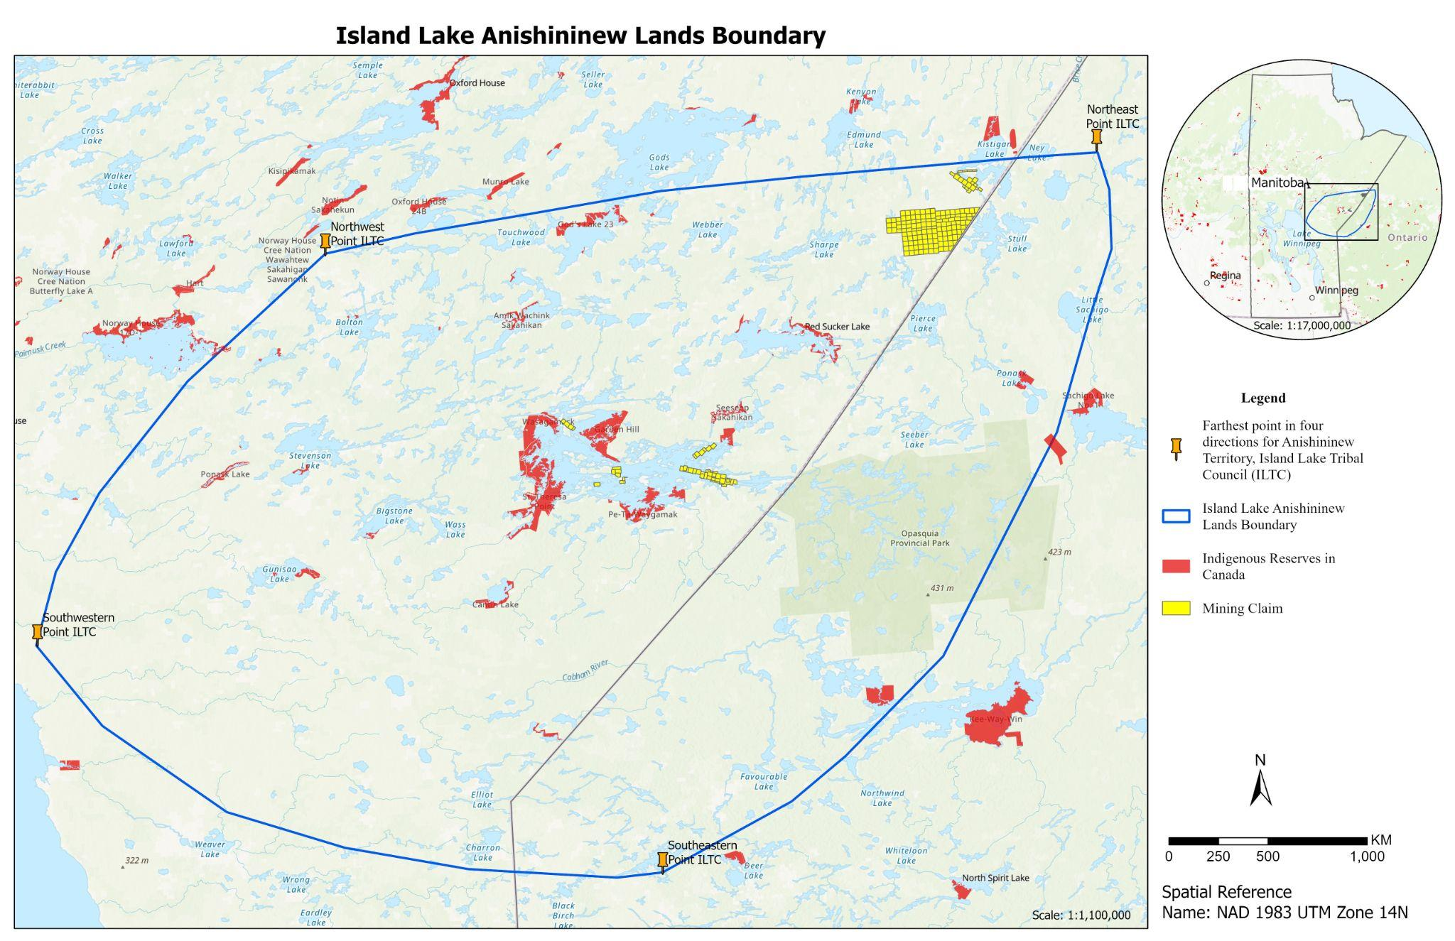 | Map of the proposed traditional territory of Island Lake First Nations.
Map 2  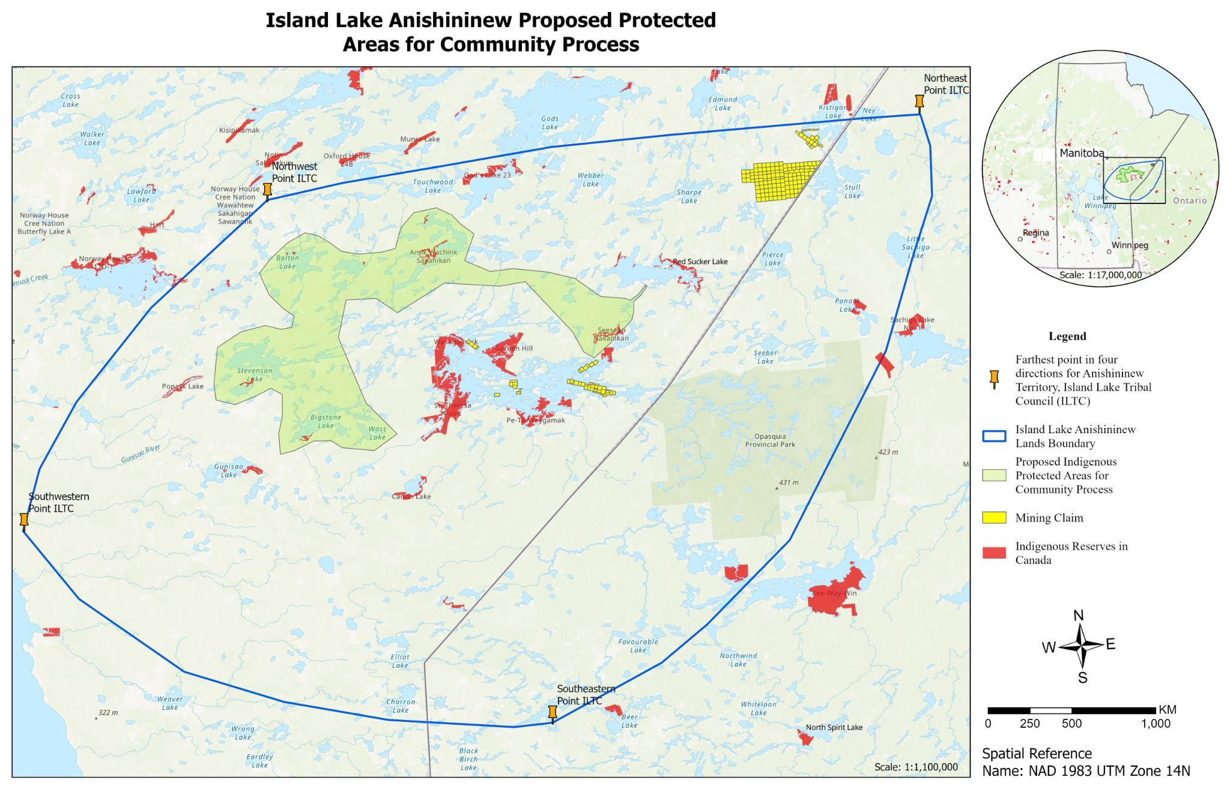 | Map of the proposed conservation area and the proposed traditional territory of Island Lake First Nation. The proposed conservation area will be subject to wider consultation with the community members, Elders, harvesters, and knowledge keepers.

F. CONSENT
By submitting this Application, I (the principal representative of the organization), have read and understand that:
- All records provided by an Applicant to ECCC in this Expression of Interest (EOI) and related communications are collected, retained and used by ECCC solely for the purposes of administering the Indigenous-Led Area-Based Conservation component of Enhanced Nature Legacy or for any further subsequent use consistent with these purposes where administered by ECCC.
- There are potentially applicable legal requirements for federal government institutions, including ECCC, to disclose records provided by an applicant to ECCC in or in relation to an Application that arise at law. In particular, there are such potentially applicable legal requirements set out in federal legislation, including in the Access to Information Act, Privacy Act, Canada Evidence Act and Library and Archives of Canada Act.
- ECCC will disclose proposed projects to other government departments for the purposes of administering the Indigenous-Led Area-Based Conservation component of Enhanced Nature Legacy. Such disclosure may meet a variety of administrative purposes, including ensuring that proposed projects are not encumbered or in conflict with existing land usage or constraints (e.g., land claim agreements). Other government departments receive access to EOI maps, project description, and additional limited information as necessary.
- For the purposes of EOI review, or a use consistent with these purposes, ECCC will provide the Canadian Wildlife Service, provinces and territories, and Indigenous Reviewers with access to all information included in this Application or in relation to this Application (such as personal, confidential or other type of information).

Organization Address:  ISLAND LAKE TRIBAL COUNCIL INC. Number. 1023. Address. 4th FLOOR, 338 BROADWAY,  Winnipeg, MB R3C 0T3 | Name of principal representative of the organization: Vincent Norman Wood
 | Title: Regional Coordinator – Lands, Resources & Environment
 | Email: vincentnwood@gmail.com
 | Phone: (204)805-2810

Signature: ________________________________________ Date: __________________________
I acknowledge that I have fully accepted the conditions and uses described herein.

OPTIONAL: Please select from the following optional opportunities related to this EOI. Project applicants are not required to agree to optional opportunities in order for applications to be retained for ILABC funding consideration.
If you are seeking match funding, ECCC can share EOI information with donors and foundations. In the event that EOI information aligns with donor and foundation mandate, goals, and interest of, these organizations will contact applicants directly; ECCC cannot guarantee the identification of match funding through this opportunity. Donors and funders will receive access to the project summary, additional limited details sufficient to identify project costs, and contact details. Please indicate if you would like your EOI information shared with donors and funders, for the purpose of seeking match funding:
x____ Yes ____ No

There may be opportunities to share EOIs with Parks Canada for funding consideration under other initiatives, such as the National Urban Parks or Ecological Corridors programs. Please indicate if you would like your EOI shared with Parks Canada:
_x___ Yes ____ No

